Objective Questions for chapter 10

- This state is like dead-end non final state and is expressed by
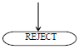
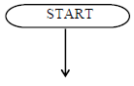
a. c.

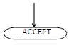
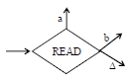
  - d.

- What the definition of Null Production ?
a. The production of the form nonterminal
b. A production is called nullable production if it is of the form
c. place where the input letters can be placed until these letters are refered again
d. The production of the form terminal

- A PUSH operator adds a new letter at ……. of STACK
- the top c. the left
- the bottom d. the right

- Consider the following CFG
S -> aaS|bbS|abX|baX|Λ
X -> aaX|bbX|abS|baS,
then the corresponding TG will be
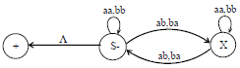
a. c.
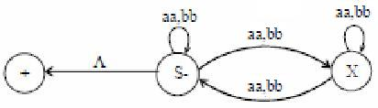

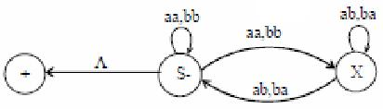
b. d. all answers are wrong

- Consider the following CFG
S -> A|bb
A -> B|b
B -> S|a
The unit production is…
a. S -> A c. S -> aa
A -> B A -> A
B -> S B -> S

b. S -> B d. all answer are wrong
A -> b
B -> a

- The derivation of a word w, generated by a CFG, such that at each step, a production is applied to the left most nonterminal in the working string, is said to be ?
a. left most derivation c. left most nonterminal
b. right most derivation d. right most nonterminal

- This state is like initial state of an FA and is represented by
a. c.

b. d.

- If a CFG has only productions of the form
nonterminal -> string of two nonterminals
then…
a. the CFG is said to be in Chomsky Normal Form (CNF).
b. the CFG is said to be in FA.
c. the CFG is said to be in Kleene
d. all answer are wrong

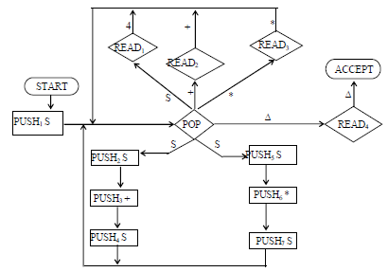

The CFG is …

- S -> S+S|S*S|4 c. S -> S+S|S*S|6
- S -> S+SS|S*S|4 d. S -> S+S|S*S|5

10. Pushdown Automaton (PDA), consists of the following….
a. An alphabet S of input letters
b. An alphabet A of input letters
c. A pushdown STACK which is initially full, with infinite many locations in two direction
d. A POP state that reads the bottom character of the STACK

